Newstead Girls’ College – Negombo
Applying for the GCE Advanced Level (2020-2022)
(For External School Applicants)

Instructions for the applicants
- Due to the current situation of Covid-19 in Sri Lanka the GCE Advanced Level Applications for the academic year 2020 - 2022 will be taken via email.
- Please forward your application form which is prepared as per the sample provided to ngcnegombo.app@gmail.com, before 30.05.2020.
- Enter the subject line of the email as INTERNAL if you are an internal applicant and EXTERNAL if you are an external applicant.
- If you are an external school applicant you should bring the completed application form, certified by the school principal when attending the interview.
- All the information given in the application should be completed and the incomplete applications will be rejected.

Basic guidelines to select the stream and the subjects for GCE (Advanced Level)
- The Bio Science, Physical Science (Maths) and Commerce streams can be studied either in Sinhala or English Medium. The Art stream can be only studied in Sinhala Medium.
- In the Commerce stream; the subject, ICT (English Medium) can be selected instead of the subject, Economics.
- In the Physical Science (Maths) stream; the subject, ICT (English Medium) can be selected instead of the subject, Chemistry.
- In the Bio Science stream, the subject, Agriculture (Sinhala Medium) can be selected instead of the subject, Physics.

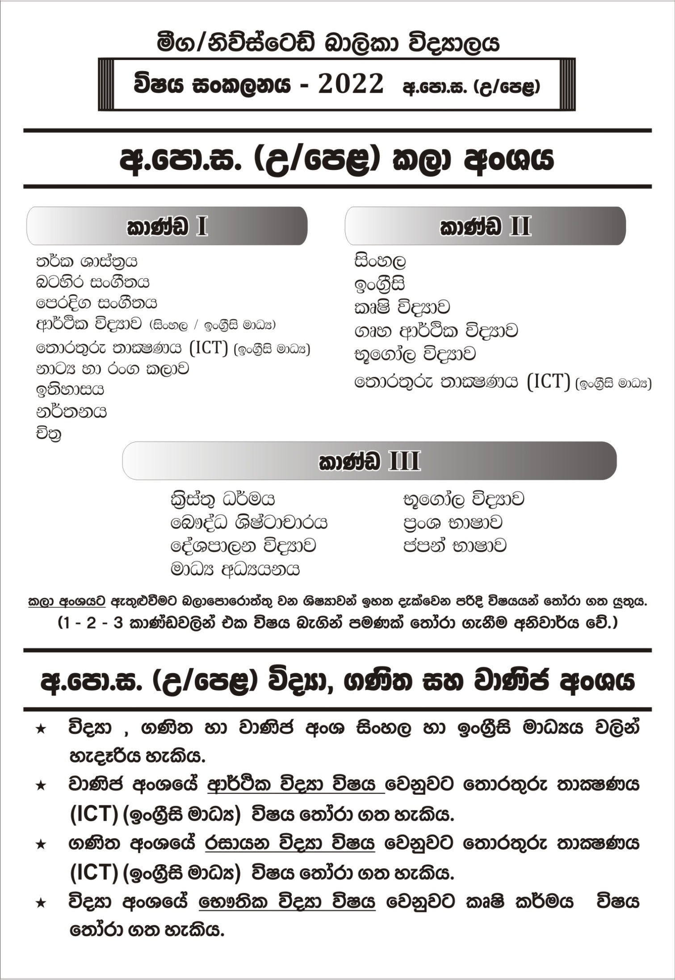Newstead Girls’ College – Negombo
The Application form for the admission of GCE Advanced Level (2020-2022)
(For External School Applicants)

Stream
Medium

- Full name of the student :
- The name with initials :
- The schools attended
          - The name of the school and address :
          - The education zone of the school :
- Date of birth :
- (i) Permanent address :
(ii) Province :
(iii) District :
- The name of father/ mother/ guardian :
- The address of father/ mother/ guardian :
- Contact number mobile : land phone :
e-mail address :
- GCE (Ordinary Level) results:

First Attempt
Index No :
 | Subject | Result
1
2
3
4
5
6
7
8
9
10

- The subjects intended to follow in GCE Advanced Level
………………….. (ii)………..………….. (iii)……………………

- (i) Is the stream that you have intended to follow in GCE Advanced Level, available in your school? ………………………..
(ii) Is the medium of the relevant subject stream that you have intended to follow in GCE Advanced Level, available in your school? ……………………..
- The achievements that you have obtained in Co Curricular Activities (All island, provincial, zonal and divisional level achievements)

- The special talents demonstrated in school ( Spoken, Announcing, Cadetting, Debating, Sports, Aesthetic, etc)

I certify that all the information mentioned above is true and correct.
……………………. ………………………
Signature of the student Father/ mother/ guardian
The Principal’s Certification
I, hereby certify that Commerce/ Arts/ Bio Science/ Physical Science (Maths) stream is available / not available in our school, the above mentioned stream is conducted / not conducted in Sinhala / English medium and subject, ……………. is available / not available in the school.

Date :……………………. ………………………
Principal’s signature and official stamp

